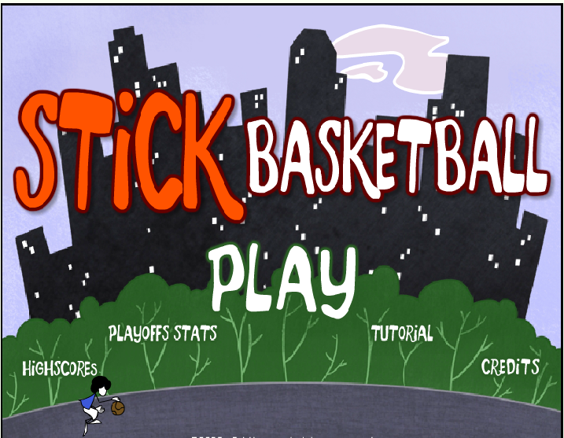

Strick basketball

Submitted by:

Kheyc E.Santiago

Submitted to:

Mr. Rn Santos

HCI INSTRUCTOR

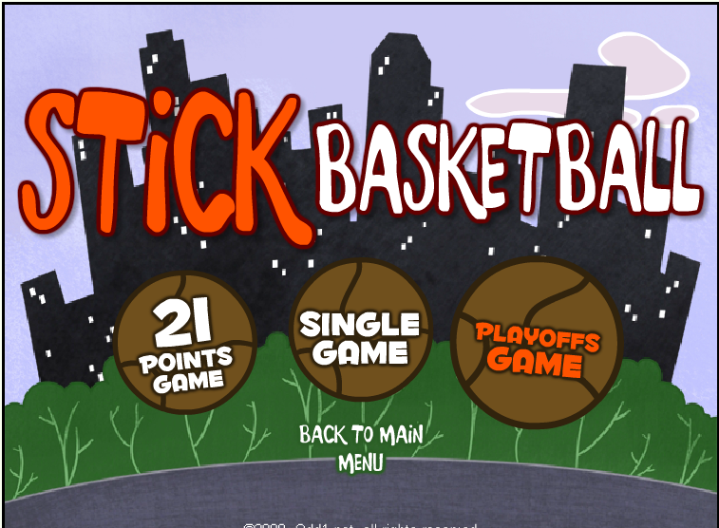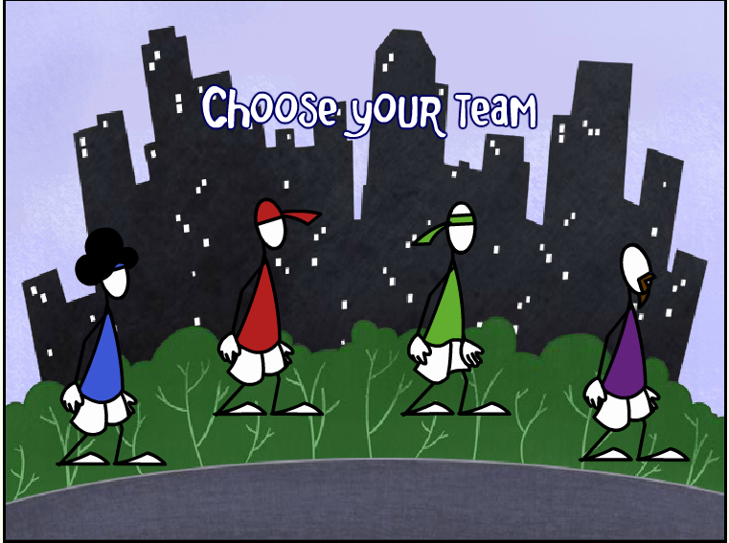

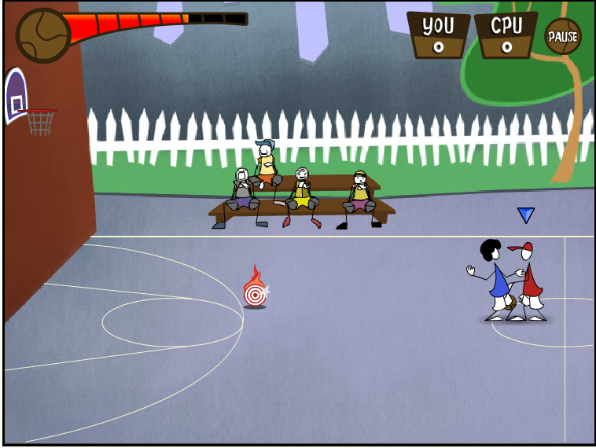

Genre: basketball

Target: ages 10 and up

Rating: Rated E 10+

Number of Player: single player

Platform: PC

Gameplay:

The Strick Basketball is a team sport in which two teams most commonly of five players each opposing one another on a rectangular court compete with the primary objective of shooting a basketball.